ACVIP App Android Version – Features list

ACVIP App Can be downloaded from Google Pley
You can search ACVIP or IAP IMMUNIZATION 2013 in google pley
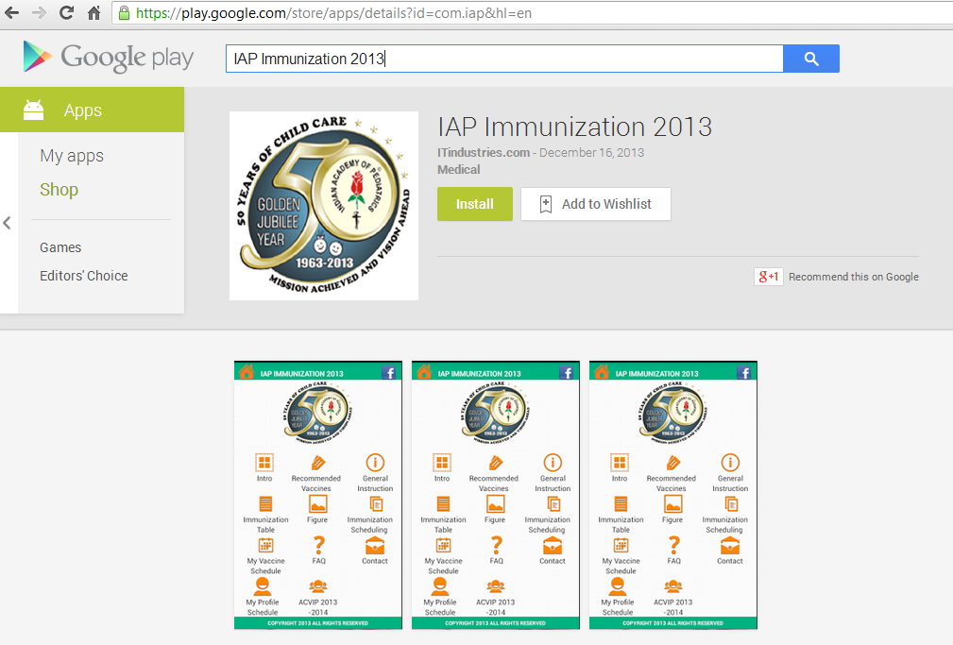

ACVIP App After installation in App dashboard – on android device

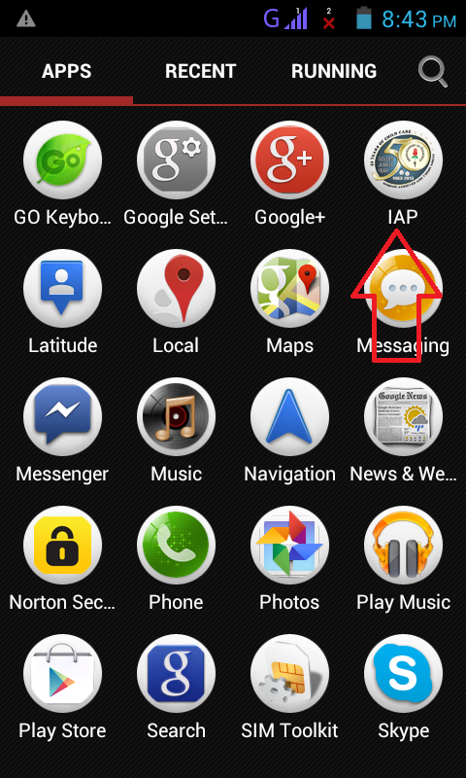

App Welcome Screen / Dashboard / Splash Screen
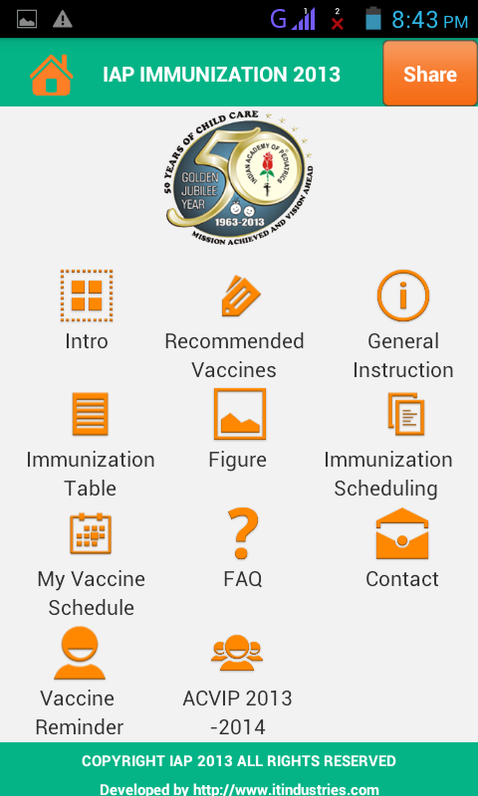

First option on dashboard is Intro – which describe about ACVIP
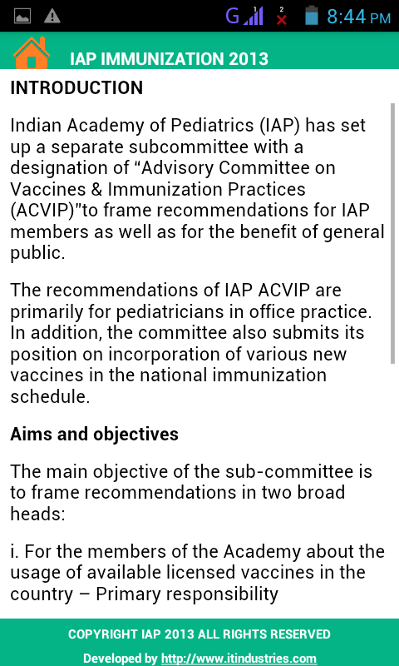
Press back key on your phone to go back to dashboard of app
Second option on dashboard is recommended Vaccines
This option have another 2 option – Routine Use & High Risk Children. Each sub option has again some vaccines option.
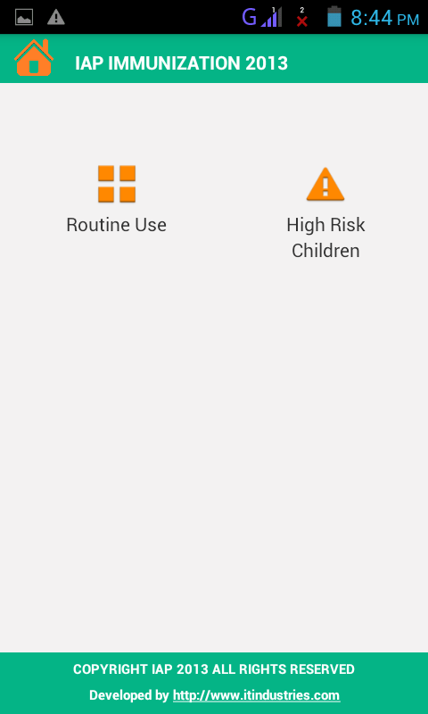
Routine Use
Touch vaccine option to open details
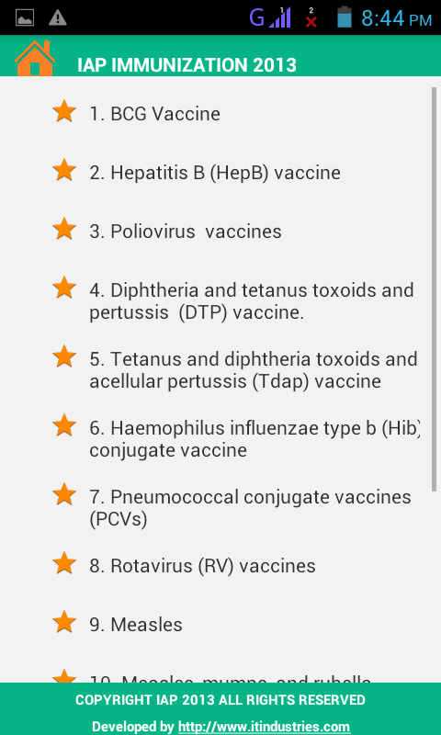

Vaccine details
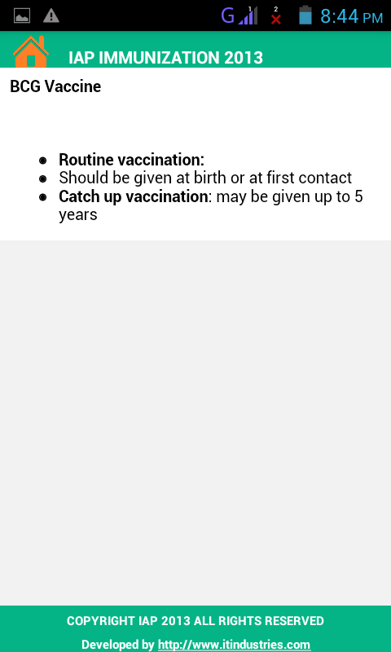
Press back key on your phone to go back one level up

High Risk Children
Touch vaccine option to open details
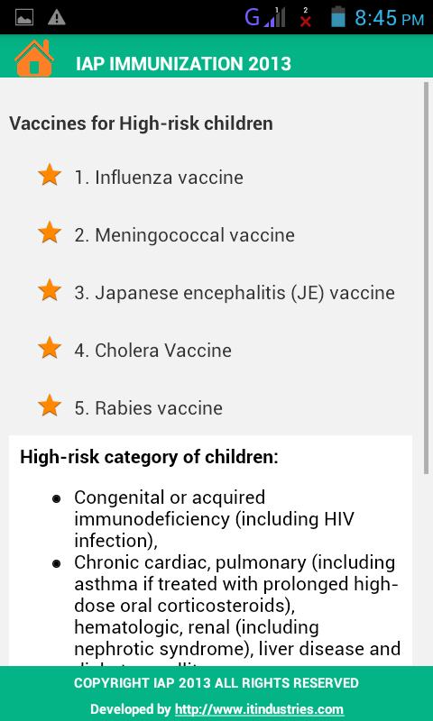
Press back key on your phone to go back one level up
Vaccine details
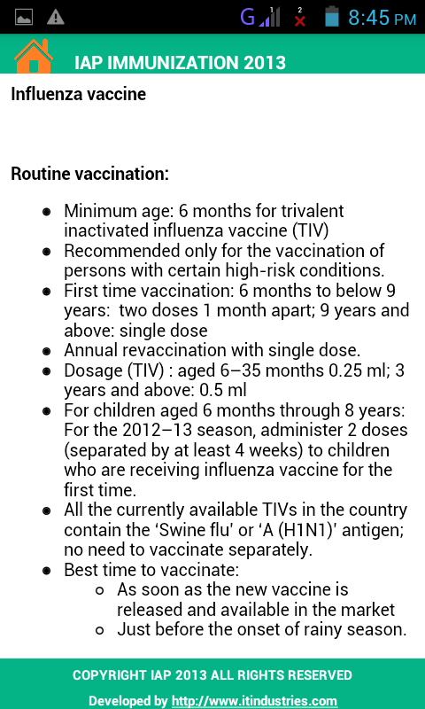
Press back key on your phone to go back one level up

Third option is General Instructions
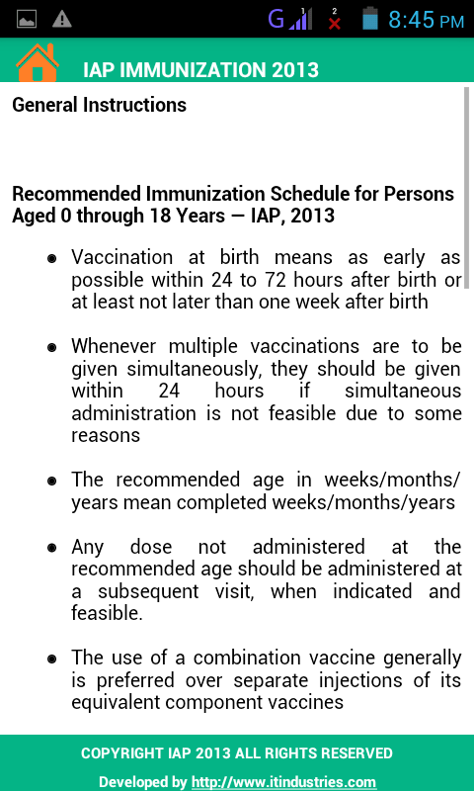
Press back key on your phone to go back one level up

Fourth option is Immunization Timetable 2013
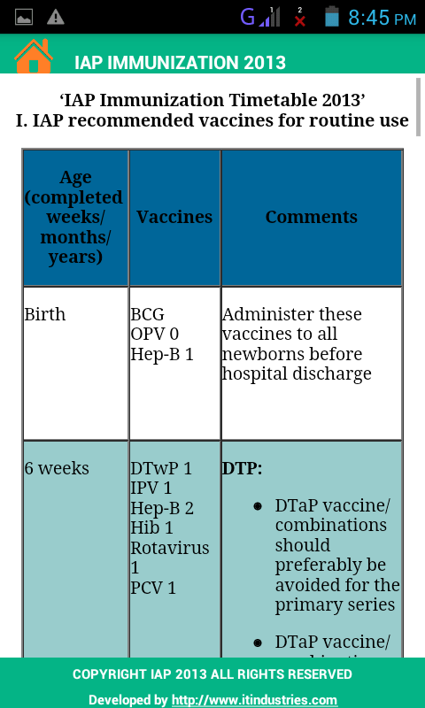
Press back key on your phone to go back one level up

Fifth option is Figure
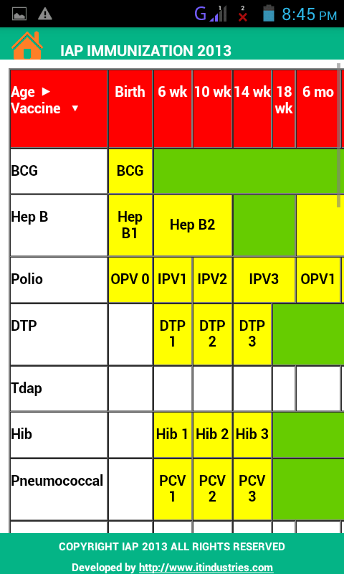

Press back key on your phone to go back one level up
Sixth option is Immunization Schedule
Here option is given to select child age.
A complete immunization scheduled will be displayed on screen according to entered age.
You can enter your email details to get complete schedule via email.
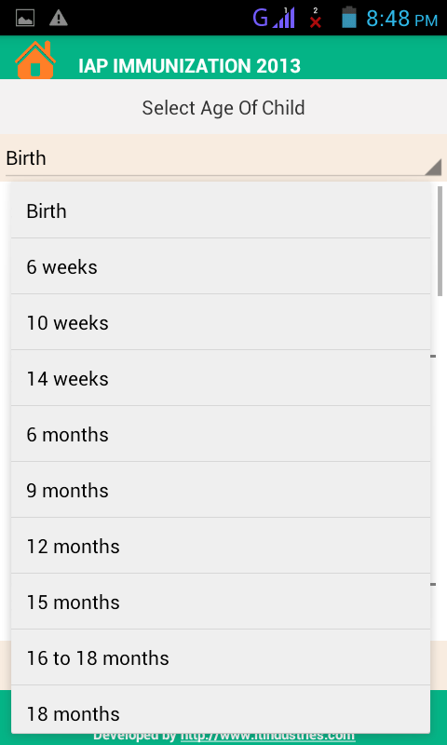

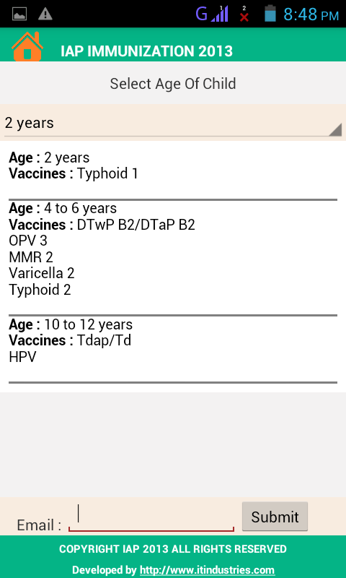

Press back key on your phone to go back one level up
Seventh Option is My Vaccine Schedule
Here option is given to select child age.
A complete immunization scheduled will be displayed on screen according to entered age.
You can enter your email details to get complete schedule via email.

Press back key on your phone to go back one level up

Eighth Option is FAQ
This section is under development we will update here some common questions & answers.

Ninth Option is Contact
We can get here contact details of ACVIP
Touch on contact numbers to open directly in your phone dialer.
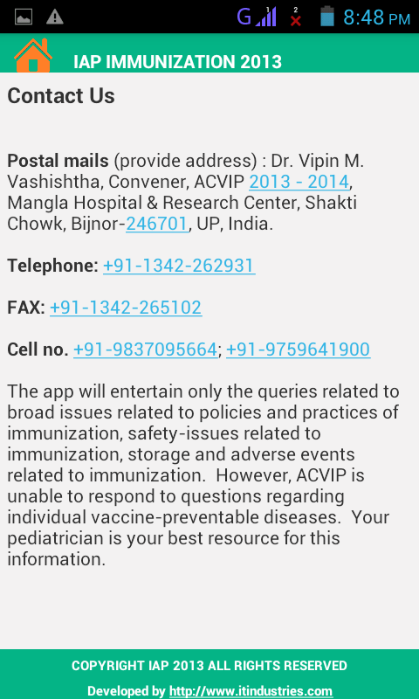
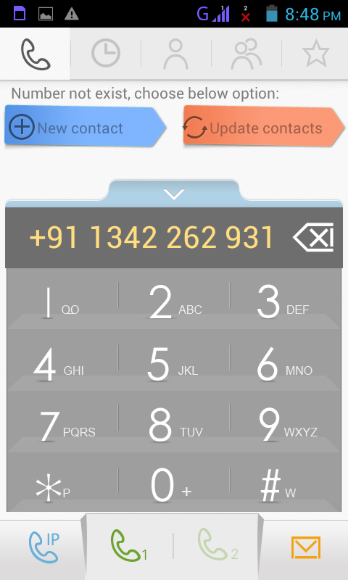
Press back key on your phone to go back one level up

Tenth Option is Vaccine Reminder
Here option is given to enter your details like name , contact details & Childs Date of birth.
These details will be updated to our server (Internet connection require)
We will send Email reminder & SMS on vaccine due dates to your entered email & contact number.
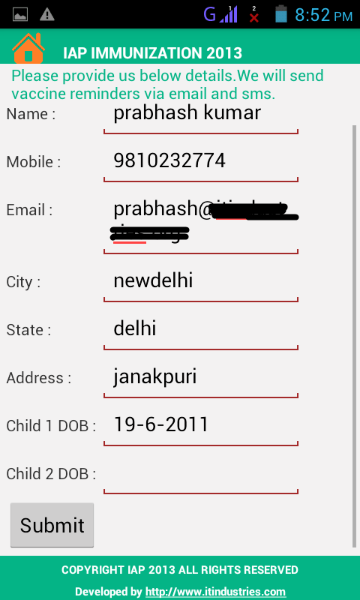
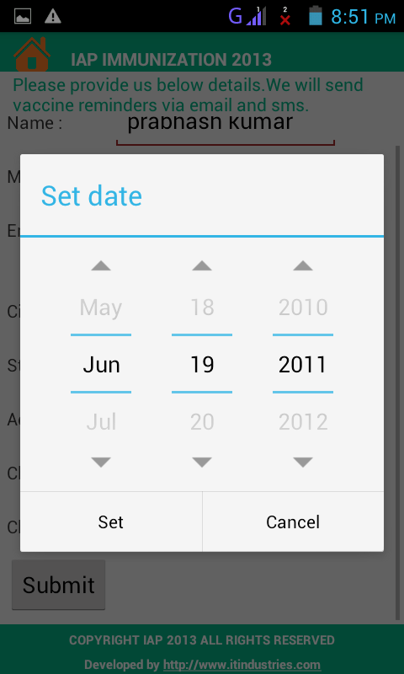

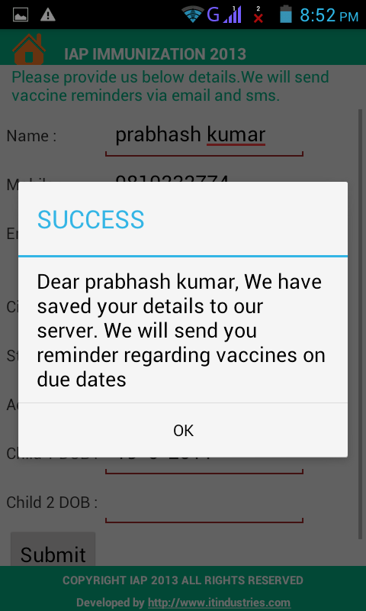
Press back key on your phone to go back one level up

Eleventh option is ACVIP 2013 – 2014
This option describe about ACVIP Team
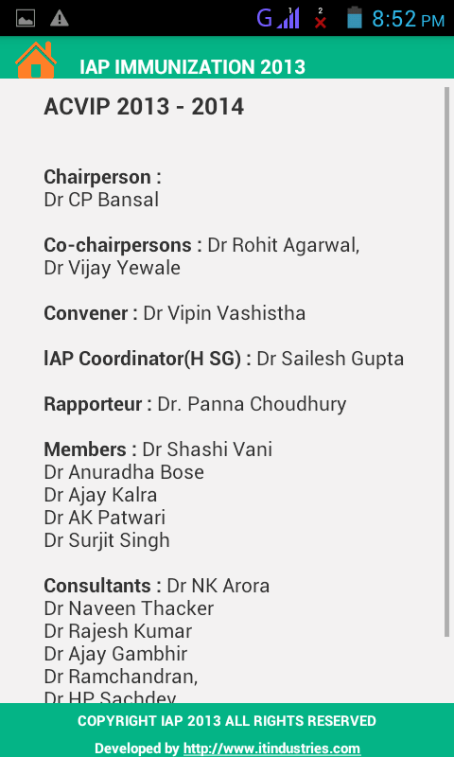

Share Option – On App dashboard in top right corner we have provided option to share this app on some major social networking websites.
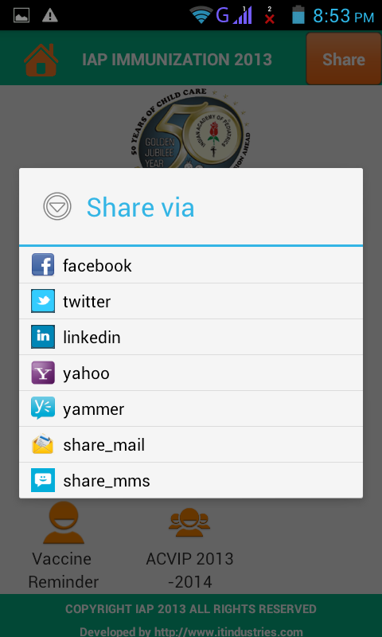
Thank You !
Powered BY ITindustries.com

